Automatic Invoice Generator

Team: Enigmas

1.Problem Statement
Many shops and retail stores still prepare invoices manually, which takes time and may lead to calculation errors. It is also difficult to store customer details and invoice records safely or search old invoices during product returns.The Automatic Invoice Generator is developed to make the billing process faster, simpler, and more accurate. It can be used in supermarkets as well as other retail stores.

2.Objectives
- To generate invoices automatically and reduce manual work.
- To store customer, product, and invoice details permanently using SQLite.
- To calculate GST based on product category.
- To apply discounts and generate the final bill correctly.
- To generate PDF invoices.
- To send invoices to customers through email.
- To maintain invoice and return history.
- To search invoices using Invoice ID or invoice image.
- To provide a simple sales dashboard for sales tracking.
- To develop an easy-to-use billing system for different types of retail stores.

3.Features
- Login & Authentication – Secure login for six billing counters.
- Customer Management – Add, update, and manage customer details.
- Product Management – Store product details with category, stock, and price.
- SQLite Database – Store customer, product, invoice, and return records permanently.
- Category-wise GST – Calculate GST based on product category.
- Discount Calculation – Apply discounts before generating the final bill.
- Invoice Generation – Generate invoices with a unique Invoice ID.
- PDF Invoice – Save invoices in PDF format.
- Email Invoice – Send invoices directly to the customer's email.
- Invoice History – View previously generated invoices anytime.
- Search Invoice – Search invoices using Invoice ID or invoice image.
- Return & Return History – Manage product returns and maintain return records.
- Sales Dashboard – Display sales details using simple graphs and reports.

4.Module Requirements
Module 1: Login & Authentication
Purpose: To allow only authorized users to access the system.
Requirements:
- Login using username and password.
- Allow six billing counters to access the system.
- Use a common password for all billing counters.
- Verify user credentials before login.
- Display the logged-in user's name after successful login.

Module 2: Customer Management
Purpose: To store and manage customer information.
Requirements:
- Add new customer details.
- Update customer information.
- Search customer records.
- Store customer data in the SQLite database.

Module 3: Product Management
Purpose: To manage product details used for billing.
Requirements:
- Add new products.
- Update product details.
- Store category, price, GST, stock, and discount details.
- Display available products.

Module 4: Invoice Generation
Purpose: To generate invoices automatically with correct calculations.
Requirements:
- Select customer and products.
- Calculate GST based on product category.
- Apply discount to the bill.
- Generate a unique Invoice ID.
- Save invoice details in the SQLite database.
- Calculate the final bill amount.

Module 5: PDF Invoice
Purpose: To generate and save invoices in PDF format.
Requirements:
- Generate the invoice as a PDF.
- Save the PDF invoice.
- Include customer, product, GST, discount, and total amount.
- Keep the invoice ready for email.

Module 6: Email Invoice
Purpose: To send the invoice to the customer's email.
Requirements:
- Send the PDF invoice to the customer's email.
- Ask the user before sending the email.
- Show a confirmation message after sending.
- Store the email status.

Module 7: Search Invoice
Purpose: To search previously generated invoices.
Requirements:
Search using Invoice ID.
Search using an invoice image.
Accept JPG and PNG invoice images.
Display invoice details if found.
Allow manual search if image search fails.

Module 8: Return & Return History
Purpose: To manage returned products and maintain return records.
Requirements:
- Allow food items to be returned within 3 days.
- Allow other products to be returned within 7 days.
- Update product stock after a successful return.
- Store return details in the database.
- Maintain return history.

Module 9: Sales Dashboard
Purpose: To display important sales information.
Requirements:
- Show total customers.
- Show total products.
- Show total invoices.
- Show total sales.
- Show low stock products.
- Display simple graphs and reports.

Module 10: SQLite Database
Purpose: To store all project data permanently.
Requirements:
- Store customer records.
- Store product details.
- Store invoice and return history.
- Store billing counter details.
- Retrieve and update records whenever required.

Module 11: Main Menu
Purpose: To provide easy navigation between all modules.
Requirements:
- Display all available modules.
- Open the selected module.
- Return to the main menu after completing a task.
- Allow the user to exit the system safely.

5.Non-Functional Requirements
- Performance: The system should generate invoices and display records quickly.
- Security: Only authorized users should be able to access the system through login.
- Reliability: Customer, product, invoice, and return data should be stored safely in the SQLite database.
- Usability: The system should be simple and easy to use for billing staff.
- Accuracy: GST, discounts, and total bill calculations should be correct.
- Availability: The system should be available whenever required during business hours.
- Maintainability: The system should be easy to update or modify in the future.
- Scalability: New products, customers, and features can be added without affecting the existing system.
- Compatibility: The system should run on computers with Python installed and support SQLite.
- Data Integrity: Stored records should remain accurate and should not be lost during normal operation.

6.Product Backlog Grooming

Product Backlog ID | User Story | Priority | Estimated Effort
PB-01 | As a user, I want to log in securely so that only authorized users can access the system. | Low | 1 Hrs
PB-02 | As a user, I want to manage customer details so that customer information can be stored and updated. | High | 3 Hrs
PB-03 | As a user, I want to manage product details with category, GST, stock, and price. | High | 4 Hrs
PB-04 | As a user, I want the system to calculate GST automatically based on product category. | Low | 1 Hrs
PB-05 | As a user, I want to apply discounts so that the final bill is calculated correctly. | Low | 1 Hrs
PB-06 | As a user, I want the system to generate invoices automatically with a unique Invoice ID. | High | 3 Hrs
PB-07 | As a user, I want to save the invoice as a PDF and send it through email. | High | 3 Hrs
PB-08 | As a user, I want to search invoices using Invoice ID or an invoice image | Medium | 3 Hrs
PB-09 | As a user, I want to return products and maintain return history according to the return policy. | Medium | 3 Hrs
PB-10 | As a user, I want to view sales information on a dashboard so that I can monitor business performance | High | 4 Hrs
PB-11 | As a user, I want all customer, product, invoice, and return data to be stored permanently in the SQLite database. | High | 5 Hrs
PB-12 | Testing, bug fixing, and final documentation. | High | 5 Hrs

7.Sprint Planning
- Sprint 1: Planning Phase (Duration: Before Submission / 1–2 Days:
- Requirement analysis and module finalization
- System design and architecture preparation
  - Preparation of project report (Objectives, Features, Requirements, etc.)
  - Final submission of report

- Sprint 2: Development Phase (Duration: 2-3 Days)
- Implementation of Customer Management module
- Implementation of Product Management module
- Development of Invoice Generation with GST calculation
- PDF generation of invoices o Email sending functionality
- Data storage implementation
- Search and Reset functionalities
- Implementation of Sales Dashboard module.
- Menu-driven system integration

- Sprint 3: Testing Phase (Duration: 1–2 Days)
- Testing of all implemented modules
- Bug identification and fixing
- Validation of inputs and outputs
- Final system integration and verification

8.Workflow
START
↓
User Login
↓
Validate Credential
↓
Display Main Menu
↓
Select Required Operation
├── Customer Management
→ Add/View/Update/Delete Customer Details
├── Product Management
→ Add/View/Update/Delete Product Details
├── Generate Invoice
→ Select Customer & Products
→ Calculate Total Amount
→ Generate Invoice
→ Save Invoice Details
├── View/Search Invoice
→ Retrieve Invoice Records from Database
└── Export Invoice
→ Save Invoice File
↓
Store/Retrieve Data using SQLite Database
↓
Return to Main Menu
↓
Exit Application
↓
END

Technologies Used
- Python – Core language for application development
- SQLite – Database storage and management
- Tkinter – GUI interface development
- GitHub – Code version control and collaboration
- VS Code – Development and testing environment
- Regex – Input validation and data checking

Acceptance Criteria
- Acceptance Criteria
- User login works with valid credentials.
- Menu options perform required operations
- Customer and product data is managed correctly.
- Invoice generation and calculations are accurate.
- Invoice records are stored and retrieved properly.
- Files are exported successfully.

Future scope
- Add online payment integration.
- Implement cloud-based data storage.
- Add advanced invoice templates.
- Develop a web/mobile application.
- Add automated report generation.

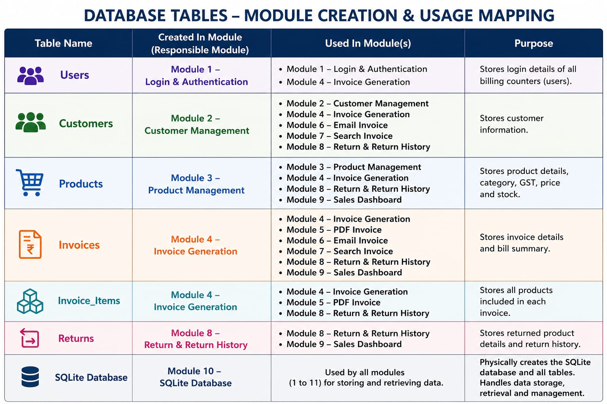
12.Table Information

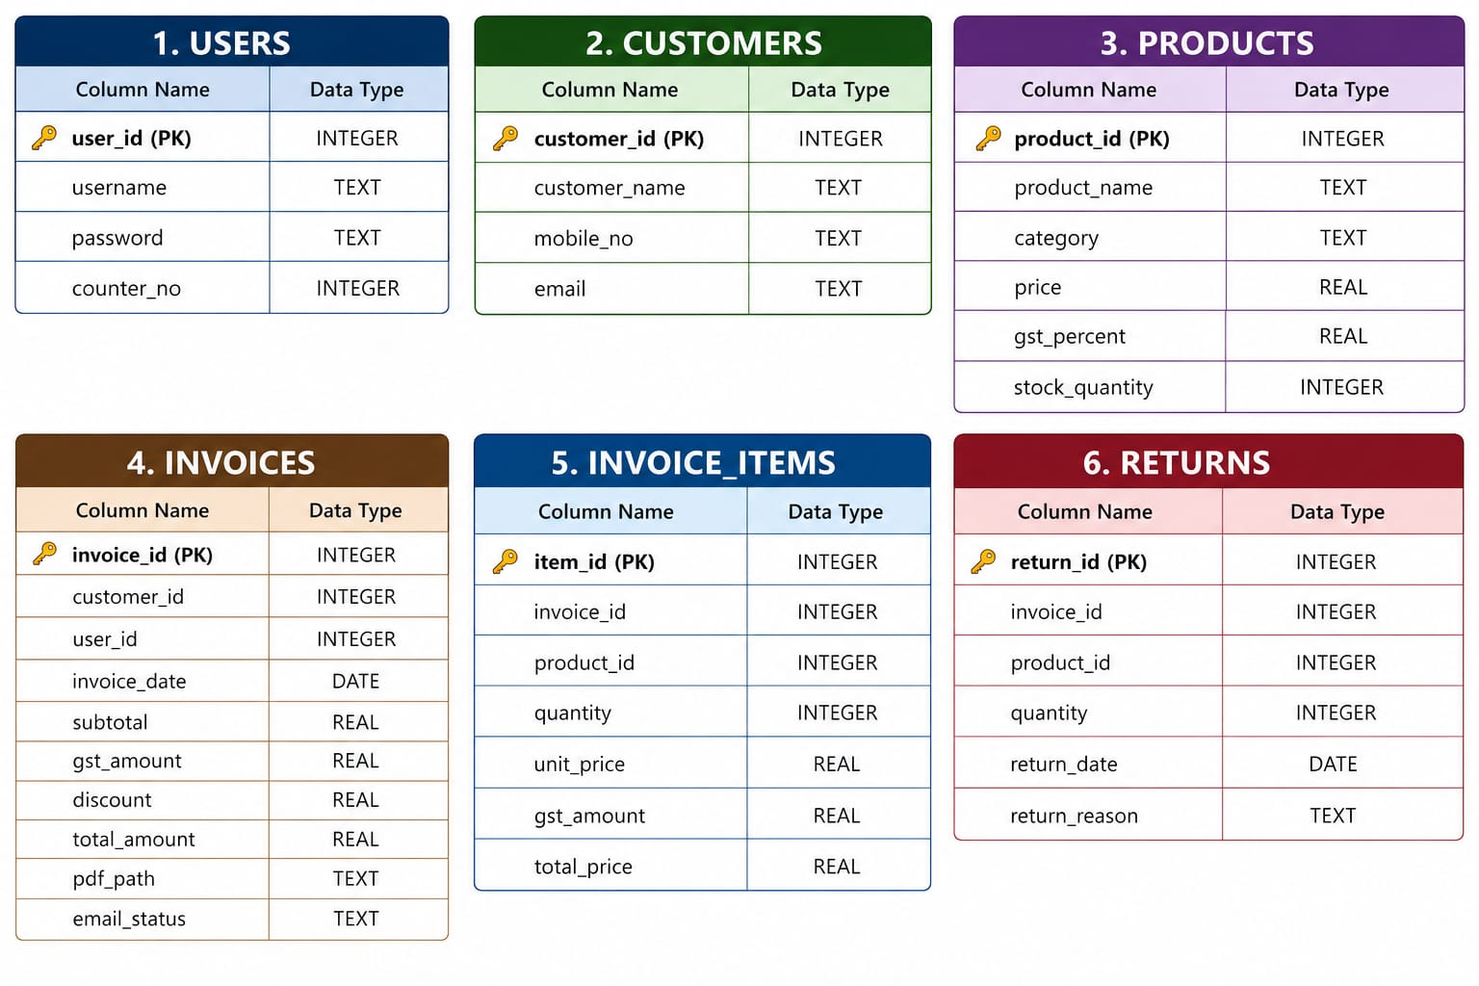

13. Task Distribution

13.Task Distribution
